# Weekly Attendance-Elementary (Detail)

# Verify that all teachers have submitted signed “Weekly Attendance Reports” on Friday (no later than the next school day).

If not submitted, follow up with an e-mail to the teacher with a copy to the administrator.

# Print Audit Listing

From the Control Table, select “Attendance Accounting” then Print Audit Listing (#1)

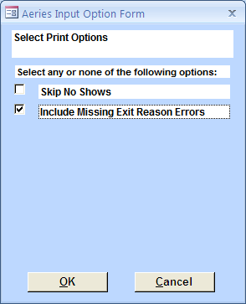

Your report will look like the following:

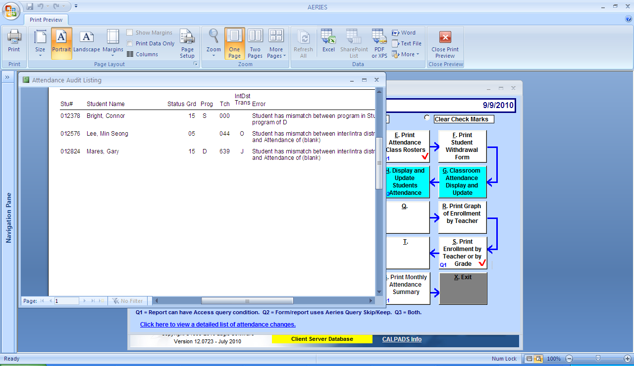

Correct errors.

**Important: It is important to keep the “Check Status” and “Show Inactive” boxes checked on page 1 of the Student Data sheet. This will give you an alert as you are enrolling or making changes to a student.**

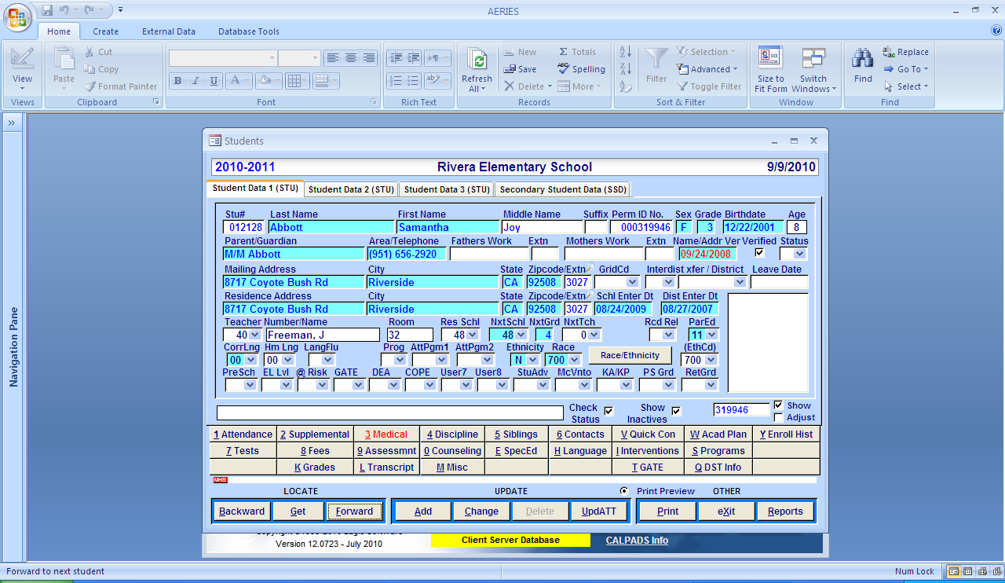

# Print Gains and Losses Report

From the Attendance Accounting table, select “Gains and Losses Report” (#2) Date will automatically default to the first day of school to the current date. Change first day to 8/24/2010. This will avoid the printing of all student names who will be listed as “Gains” on the first day.

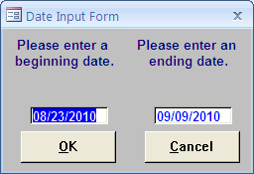

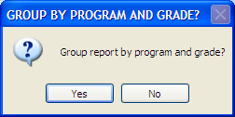 Click on “yes”

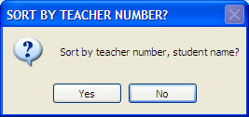 Click on “yes”

***If you run this report from the first day of school, all students will be listed for each grade as a “Gain”***

***The first month of school will have a “0” Carry Forward, All students are listed as “Gains”***

Compare this report with your manually-kept “Accessions & Losses Report” for the same period. The two reports should reconcile, by Instructional setting. Reconciliation of this report will help find any errors made with changes in teacher, instructional setting or with the enrollment/withdrawal of students.

# Input any Saturday School Attendance

If your site holds Saturday School, use the Saturday School rosters to change qualified absences to the Saturday Make-Up code, “M”. Verify that the absences qualify and that the dates used are not after the Saturday School served.

Select Student Data from the Control table. Do a “Get” to find the student

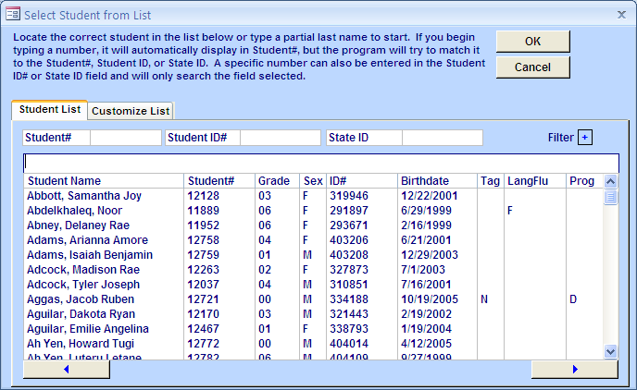

When the student is selected, open up the “Attendance” tab.

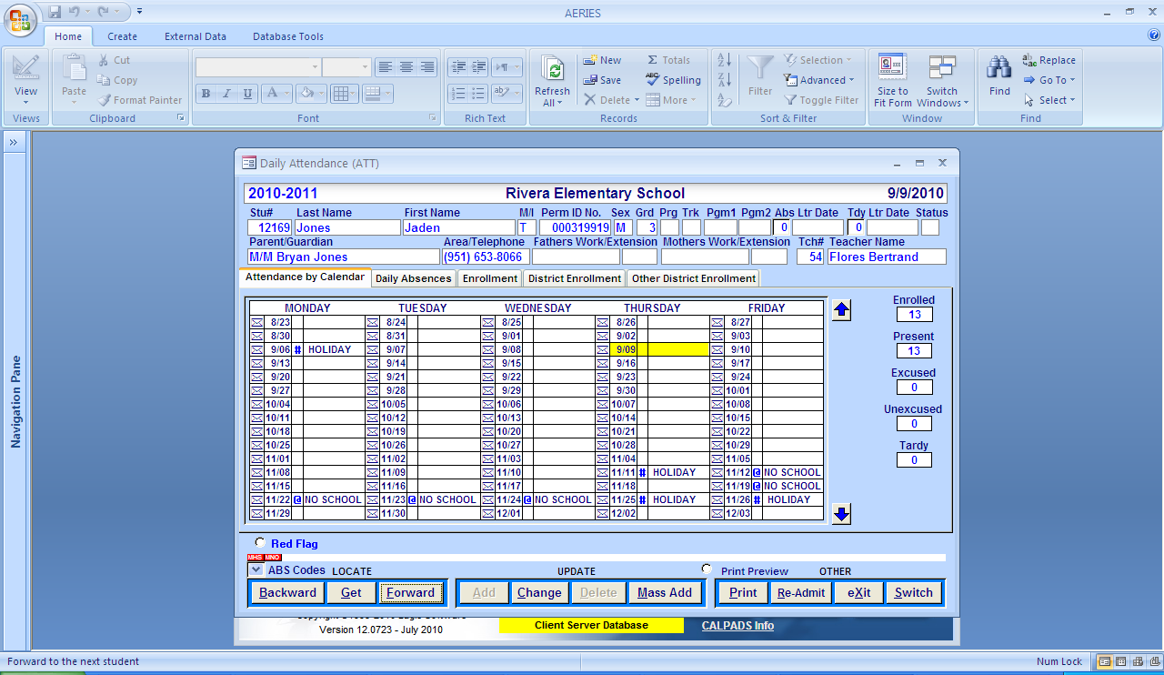

Go to the date of the absence, change to “M”. Enter a note under the “envelope”:

Served Sat school on 9/18/10

For ill, initials & entry date

# Submit Enrollment Counts to Human Resources (Jenny Ramos) every Friday and to Attendance Accounting (Gloria Harpster) on the last Friday of each Reporting Period.

From the Attendance Accounting table, select Print Enrollment by Teacher or Grade (S) select all grades except 15 (pre-school)

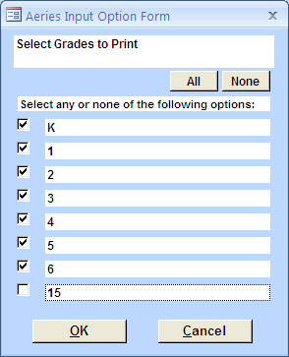

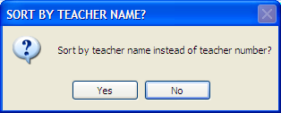 Select “yes”

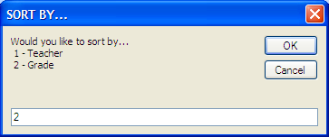 Select by grade

This report will give you enrollment numbers as of the date run. For consistency and accuracy, always run the report on Friday.

After adjusting the totals for Sp Ed and Home Hospital, scan or fax the report to Jenny Ramos